**How to change the orientation in specific page using .NET PDF library**

The Syncfusion Essential® PDF is a [**.NET PDF library**](https://www.syncfusion.com/document-processing/pdf-framework/net) used to create, read, and edit PDF documents. Using this library, you can change the Orientation on a specific page for an existing document using C# and [**VB.NET**](http://vb.net/).

**Steps to change the Orientation on a specific page for an existing document programmatically**

1. Create a new console application project.A screenshot of a computer

   AI-generated content may be incorrect.
2. Install the [**Syncfusion.Pdf.Net.Core**](https://www.nuget.org/packages/Syncfusion.Pdf.Net.Core) NuGet package as a reference to your console application from [**Nuget.org**](https://www.nuget.org/).

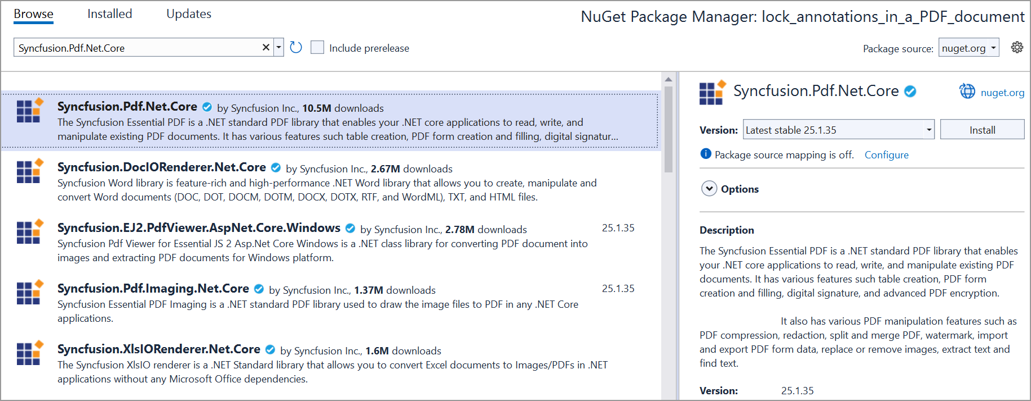

1. Include the following namespaces in the Program.cs file.

**C#**

using **Syncfusion**.Pdf.Graphics;

using **Syncfusion**.Pdf.Parsing;

using **Syncfusion**.Pdf;

using **Syncfusion**.Drawing;

[**VB.NET**](http://vb.net/)

**Imports** **Syncfusion**.Pdf.Graphics

**Imports** **Syncfusion**.Pdf.Parsing

**Imports** **Syncfusion**.Pdf

**Imports** **Syncfusion**.Drawing

1. Use the following code sample in Program.cs to change the Orientation on a specific page for an existing document.

**C#**

//Load a PDF document.

**FileStream** docStream = **new** **FileStream**("../../../Data/Barcode.pdf", **FileMode**.Open, **FileAccess**.Read);

**PdfLoadedDocument** loadedDocument = **new** **PdfLoadedDocument**(docStream);

//Create a new PDF document.

**PdfDocument** document = **new** **PdfDocument**();

//Set margin.

document.PageSettings.Margins.All = 0;

**for** (int i = 0; i < loadedDocument.Pages.Count; i++)

{

//Load the page.

**PdfLoadedPage** loadedPage = loadedDocument.Pages[i] **as** **PdfLoadedPage**;

//Create the template from the page.

**PdfTemplate** template = loadedPage.**CreateTemplate**();

//Add the section to the document.

**PdfSection** section = document.Sections.**Add**();

section.PageSettings.Margins.All = 0;

section.PageSettings.Size = **new** **SizeF**(loadedPage.Size.Width, loadedPage.Size.Height);

**if** (i == 0)

{

//Add the page orientation.

section.PageSettings.Orientation = **PdfPageOrientation**.Landscape;

}

**else**

{

//Add the page orientation.

section.PageSettings.Orientation = **PdfPageOrientation**.Portrait;

}

**PdfPage** page = section.Pages.**Add**();

//Create the graphics.

**PdfGraphics** graphics = page.Graphics;

//Draw the template.

graphics.**DrawPdfTemplate**(template, **PointF**.Empty, **new** **SizeF**(page.Size.Width, page.Size.Height));

}

//Create file stream.

using (**FileStream** outputFileStream = **new** **FileStream**(**Path**.**GetFullPath**(@"Output.pdf"), **FileMode**.Create, **FileAccess**.ReadWrite))

{

//Save the PDF document to the file stream.

document.**Save**(outputFileStream);

}

//Close the document.

document.**Close**(true);

[**VB.NET**](http://vb.net/)

' Load a PDF document.

Dim docStream As New FileStream("../../../Data/Barcode.pdf", FileMode.Open, FileAccess.Read)

Dim loadedDocument As New PdfLoadedDocument(docStream)

' **Create** a **new** PDF document.

**Dim** document **As** **New** **PdfDocument**()

' Set margin.

document.PageSettings.Margins.All = 0

For i As Integer = 0 To loadedDocument.Pages.Count - 1

' **Load** the page.

**Dim** loadedPage **As** **PdfLoadedPage** = **TryCast**(loadedDocument.**Pages**(i), **PdfLoadedPage**)

' Create the template from the page.

Dim template As PdfTemplate = loadedPage.CreateTemplate()

' **Add** the section to the document.

**Dim** section **As** **PdfSection** = document.Sections.**Add**()

section.PageSettings.Margins.All = 0

section.PageSettings.Size = **New** **SizeF**(loadedPage.Size.Width, loadedPage.Size.Height)

**If** i = 0 **Then**

' Add the page orientation.

section.PageSettings.Orientation = PdfPageOrientation.Landscape

Else

' **Add** the page orientation.

section.PageSettings.Orientation = **PdfPageOrientation**.Portrait

**End** **If**

**Dim** page **As** **PdfPage** = section.Pages.**Add**()

' Create the graphics.

Dim graphics As PdfGraphics = page.Graphics

' **Draw** the template.

graphics.**DrawPdfTemplate**(template, **PointF**.Empty, **New** **SizeF**(page.Size.Width, page.Size.Height))

**Next**

' Create file stream.

Using outputFileStream As New FileStream(Path.GetFullPath("Output.pdf"), FileMode.Create, FileAccess.ReadWrite)

' **Save** the PDF document to file stream.

document.**Save**(outputFileStream)

**End** **Using**

' Close the document.

document.Close(True)

Note: Changing the document orientation may cause the page content to stretch or shrink due to the changes in page size dimensions.

A complete working sample can be downloaded from [**ChangePageOrientation.zip**](https://www.syncfusion.com/downloads/support/directtrac/general/ze/Change_Page_Orientation-1855265509.zip).

By executing the program, you will get the PDF document as follows.

Take a moment to peruse the documentation for [**working with pages**](https://help.syncfusion.com/file-formats/pdf/working-with-pages). You can find options like inserting, rotating, importing, and rearranging the pages from an existing document, removing the pages, and splitting a PDF file into individual pages.

Refer [**here**](https://www.syncfusion.com/document-processing/pdf-framework/net) to explore a rich set of Syncfusion Essential® PDF features.

**Conclusion**  
I hope you enjoyed learning about how to change the orientation in specific page using .NET PDF library.

You can refer to our [**.NET PDF library**](https://www.syncfusion.com/document-processing/pdf-framework/net) page to know about its other groundbreaking feature representations and documentation, and how to quickly get started for configuration specifications. You can also explore our [**.NET PDF library Example**](https://www.syncfusion.com/demos/fileformats/pdf-library) to understand how to create and manipulate data.

For current customers, you can check out our [**ASP.NET**](http://asp.net/) Core Components from the [**License and Downloads**](https://www.syncfusion.com/sales/teamlicense) page. If you are new to Syncfusion®, you can try our 30-day [**free trial**](https://www.syncfusion.com/downloads/aspnetmvc-js2) to check out our other controls.

If you have any queries or require clarifications, please let us know in the comments section below. You can also contact us through our [**support forums**](https://www.syncfusion.com/forums), [**Direct-Trac**](https://support.syncfusion.com/create), or [**feedback portal**](https://www.syncfusion.com/feedback/aspnet-core?control=pdf). We are always happy to assist you!